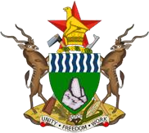 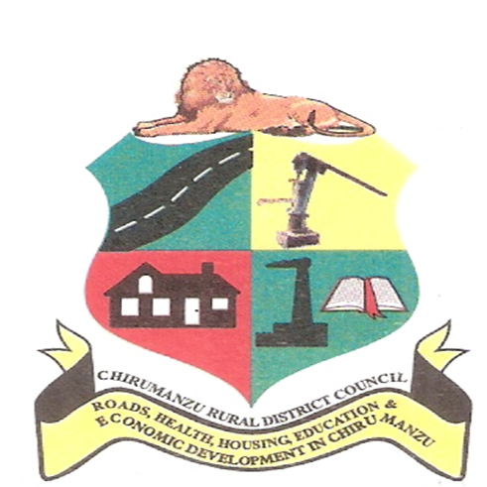

**CHIRUMANZU RURAL DISTRICT COUNCIL**

**MASTER PLAN (2025-2040)**

**Executive Summary**

Prepared By: **Dr Andrew Chigudu** (Lead Planner)

**June 2024**

1. **Introduction and Background**

Chirumanzu Rural District Council (RDC) is a pivotal local authority in Chirumanzu District, Midlands Province, Zimbabwe. This report outlines the Chirumanzu Master Plan, developed in alignment with Zimbabwe’s Vision 2030 and the national call for improved service delivery and modernization of local authorities. The master plan aims to guide the growth and development of Chirumanzu over the next 15 years, addressing key challenges and leveraging opportunities for sustainable rural and urban development.

1. **Report of Study**

The Report of Study provides a comprehensive situational analysis of Chirumanzu Rural District Council, encompassing the planning boundary of the council area and extending to adjacent districts. The study employed qualitative and quantitative research methods to assess biophysical, socio-cultural, and economic conditions. It identified critical planning issues, including infrastructure deficiencies, environmental challenges, and opportunities in water security and tourism.

* 1. **Planning Boundary**

The planning boundary for Chirumanzu RDC includes the administrative limits of the district. This boundary was essential in assessing the broader impact of development and ensuring comprehensive planning strategies.

* 1. **Data Collection Methodology**

Data collection utilised a combination of methodologies, including stakeholder interviews, focus groups, and site visits. Quantitative data on demographics, land use, and infrastructure were complemented by qualitative insights into community needs and aspirations. This approach provided a holistic understanding of current conditions and future development prospects.

* 1. **Major Issues from the Study**

Chirumanzu District faces significant economic and developmental challenges, primarily due to the dominance of service and light industry and the informal sector, which has led to high unemployment rates and an economic slowdown. The district also struggles with physical and environmental issues such as deforestation, pollution, and overgrazing. Population and employment issues are exacerbated by high population growth, a skewed population structure, and challenges within the informal sector. Additionally, the mining sector faces land degradation, environmental challenges, and illegal small-scale mining activities, while the agricultural sector is hindered by reliance on rain-fed farming, poor soil quality, and insufficient market infrastructure.

Infrastructure and social amenities in Chirumanzu are underdeveloped, with significant backlogs in housing supply, inadequate educational and healthcare facilities, and limited industrial development. The district’s infrastructure issues include challenges with water supply and sanitation, poor road conditions, inadequate public transport services, and insufficient sewer treatment facilities. The tourism sector is constrained by a lack of financial resources, absence of supporting infrastructure, utility supply issues, and weak public-private partnerships, contributing to an unclear destination image and low local appreciation.

1. **The Written Statement**

The Written Statement outlines the goals, objectives, policies, and development proposals for Chirumanzu RDC. It is informed by the findings of the Report of Study and aims to address current challenges while leveraging opportunities for sustainable development. Goals include improving infrastructure, enhancing service delivery, promoting economic diversification, and preserving cultural heritage.

* 1. **Goals and Objectives**

The master plan for Chirumanzu Rural District Council aims to address key challenges and leverage opportunities for sustainable development through the following goals and objectives:

* **Infrastructure Development**: Upgrade and expand road networks, water supply, sanitation, and energy infrastructure to support economic growth and improve the quality of life for residents. Enhance public transport services and develop termini facilities to facilitate efficient mobility.
* **Social Services**: Upgrade and expand hospitals, clinics, primary, secondary, and tertiary educational institutions to support the community's health and educational needs. Address disparities in school enrolment and improve the condition of educational facilities.
* **Service Delivery**: Ensure universal access to healthcare, education, and public services to enhance social equity and community well-being. Focus on improving service delivery in both urban and rural settings.
* **Economic Diversification**: Promote tourism, agriculture, and light and service industries to create jobs and stimulate local economic growth. Develop market infrastructure to support agricultural activities and enhance local commerce.
* **Environmental Sustainability**: Protect natural resources, mitigate environmental risks, and promote sustainable land use practices. Address deforestation, pollution, overgrazing, and the encroachment of grazing lands, ensuring sustainable development.
* **Housing Development**: Address the housing supply backlog by developing new housing projects and improving infrastructure and services in existing residential areas, both urban and rural.
* **Commercial and Industrial Development**: Encourage industrial development by allocating land for light and service industries and addressing challenges in operationalizing industrial areas. Foster public-private partnerships to drive industrial growth.
* **Population and Employment Management**: Develop strategies to manage high population growth and improve employment opportunities, particularly within the informal sector. Enhance skills training and vocational education to boost employment prospects.
* **Tourism Sector Enhancement**: Develop tourism infrastructure, enhance financial and intervention capacities, and promote local appreciation for tourism. Improve the district's destination image and strengthen public-private partnerships to attract tourists.
* **Agricultural Development**: Support rain-fed and irrigated agriculture, improve soil quality, and develop market infrastructure. Promote sustainable agricultural practices to ensure long-term productivity and food security.
  1. **Policies and Proposals**

In addressing the challenges and opportunities outlined in Chirumanzu Rural District Council Master Plan, several key policies and proposals are crucial to ensure sustainable development across various sectors.

Infrastructure development will be pivotal in laying the foundation for economic growth and improved quality of life. Policies should prioritise the expansion and maintenance of road networks to connect rural communities and urban centers, enhancing accessibility for residents and businesses alike. Proposals include investing in water supply and sanitation infrastructure to ensure reliable access to clean water and proper sanitation facilities across the district. Additionally, promoting renewable energy sources and upgrading energy infrastructure will be essential to meet growing demand sustainably.

Enhancing social services involves policies aimed at upgrading healthcare facilities and educational institutions. Proposals should focus on improving the quality of healthcare services by equipping hospitals and clinics with modern medical equipment and ensuring adequate staffing. Investing in the expansion and improvement of schools at all levels, from primary to tertiary, will address disparities in educational access and quality, supporting lifelong learning and skill development among the population. Initiatives to increase school enrollment rates, particularly among marginalized communities, should be prioritised to foster a well-educated and healthy population base.

To stimulate economic diversification, policies should support the growth of tourism, agriculture, and light industries. Proposals could include developing tourism infrastructure such as accommodations and attractions to attract more visitors to the district's natural and cultural heritage sites. Encouraging investment in agricultural activities through improved market infrastructure and sustainable farming practices will bolster food security and income generation for rural households. Promoting small-scale industries through targeted support and fostering entrepreneurial skills among the youth and women will diversify the local economy, creating employment opportunities and reducing dependence on traditional sectors.

1. **Conclusion**

In conclusion, the Chirumanzu Rural District Council Master Plan lays out a strategic blueprint for sustainable development, poised to tackle present challenges while capitalizing on emerging opportunities for growth. Through the proactive implementation of proposed policies and initiatives, the Council aims to fortify the district's resilience, elevate the standard of living for its residents, and align closely with the developmental aspirations outlined in Zimbabwe's Vision 2030. In essence, the Chirumanzu RDC Master Plan embodies a forward-thinking approach designed to foster inclusive growth, environmental stewardship, and community well-being. Through diligent execution and collaborative partnerships, the Council endeavours to realize its vision of a prosperous district where every resident can prosper and contribute meaningfully to Zimbabwe's overarching development goals.